**Frogger Style Top-Down Game:**

**Moving Objects** (All moving objects aside from Arrows will have 2 or 3 step animations along with movement)**:**

1. Treasure Hunter (player)

* Movement: Horizontal and vertical, but only one at a time on arrow key presses
* Generation: Bottom of the screen in the same place every time the user loses a life or enters a temple
* Sprites:
* A description...A description...A description...A description...A description...A description...
* Credit: <http://spritedatabase.net/files/snes/571/Sprite/Red.png>

1. Cars/Logs/Alligators

* Movement: Horizontal one way, direction depending on row generated
* Generation: Randomly at the left or right edge depending on row. All cars/logs/alligators in the same row will move the same direction at the same speed.
* Sprites:
* A description...A description...A description...A description...
* Credit: <http://spritedatabase.net/files/neogeo/836/Sprite/MSCar2.gif>
* 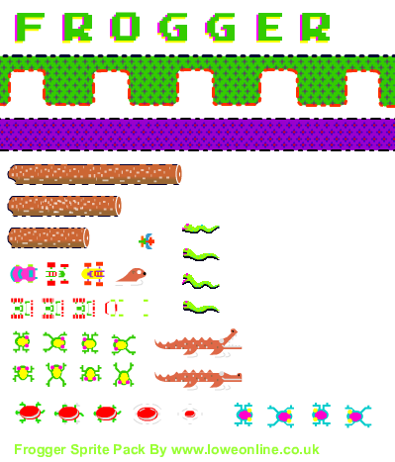
* Credit: <http://www.swish-designs.co.uk/blog/?p=1331>
* A description... A description...A description...A description...
* Credit: <http://zeldapower.com/images/others/foe/sprites/Crocodile_snapping1.gif> <http://zeldapower.com/images/others/foe/sprites/Crocodile_swimming.gif>

1. Holy Grail

* Movement: Random horizontal and vertical at the same time, changes with timer. Moving randomly around the screen
* Generation: Random off-screen and then moves onscreen
* Note: Gives player extra life
* Sprite:
* 
* Credit: <http://officialpetsociety.files.wordpress.com/2011/09/medieval-goblet.png>

1. Guardians

* Movement: Horizontal back and forth in their set boundaries (1-3 Guardians, covers whole horizontal boundary)
* Generation: Random within their set boundaries at the beginning of a level/life
* Note: Shoot Arrows vertically down the screen at random intervals within a set time range
* Sprite:
* A description...A description...A description...A description...
* Credit: <http://spritedatabase.net/file/9197>

1. Arrows

* Movement: Vertically down the screen at constant speed
* Generation: On random intervals within a set time frame always at the location of the shooting Guardian
* Sprite:
* A description...
* Credit: See Guardian

1. Temples

* Movement: None
* Generation: Always at the same places on the top of the screen
* Note: 5 temples are the end goals for the treasure hunter
* Sprite:
* A description...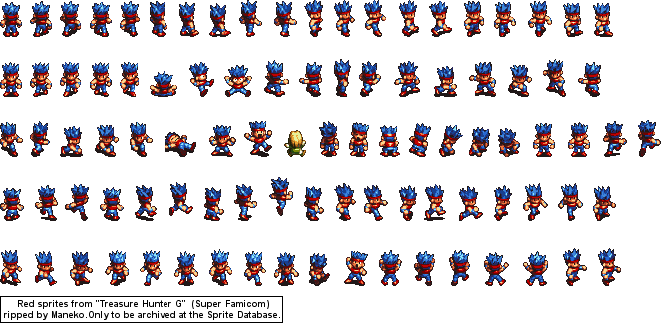A description...
* Credit: <http://images.wikia.com/kirby/en/images/d/d2/KEY_Pyramid_sprite.png>

1. River

* Movement: None, just rushing water animation
* Generation: Always in the same place
* Note: Used for object detection of falling off of a log
* Sprite:
* 
* 
* 
* Credit: <http://img393.imageshack.us/img393/730/water6cx.png>

**Basic Functionality**

* Player moves the treasure hunter with the arrow keys: up, down, left, and right
  + One move per press, can’t just hold down
* Trying to get treasure hunter into temple.
  + Once a treasure hunter has entered a temple, a new treasure hunter cannot enter the same temple.
  + Total of 5 temples, once 3 have been entered, all are cleared.
* To get to temple, must first dodge cars along a desert path; then must jump across logs to get to temple.
  + All the while, the Guardians will be shooting Arrows.
  + If the player steps on a gator, then the player loses a life.
  + If the player gets hit by a car, then the player loses a life.
  + Losing a life will change the player sprite to a skull and crossbones, and then reset the player back to the start.
* Player will start with three lives.
  + Holy Grails will appear randomly with a small chance throughout the game and if the user hits one then he/she will be given another life.
* Game will have a timer, if the player does not make it to the temple within a certain time, a boulder will roll across the screen and kill the treasure hunter, causing the player to lose a life.
  + Timer will be the same for all levels.
* When the player gets to a temple, he/she will earn points equal to the amount of time left times a difficulty factor.
  + Difficulty factor will start at 1.25 and be squared for every difficulty level. (1.25, 1.56[25], 2.44[140625], 5.96[046448], 35.52[71368], etc.)
  + Difficulty factor will increase with each level.
* Each level will be getting the treasure hunter into an unoccupied temple 3 times. During all three times the speed of all objects will be the same.
  + When a level is completed, the user moves on to the next level, where everything moves faster.
  + This continues indefinitely until the user loses.
  + The user’s movement speed will also increase, but the limiting factor is the user’s reaction time. Thus after a certain point it will be impossible to beat the level.

**Object Detection:**

* For the player to be securely on a log, road, or temple, at least half of the player’s sprite must be on the log, road, or temple (as opposed to being on the river).
* For the player to be hit by a Holy Grail, car, or Arrow, any overlap of the player’s sprite with the respective Holy Grail, car, or Arrow’s sprite will result in a collision.
* For alligators, the player’s sprite must have at least 1/3 of overlap for a collision to be detected.

**Game Layout**

* Opening Screen

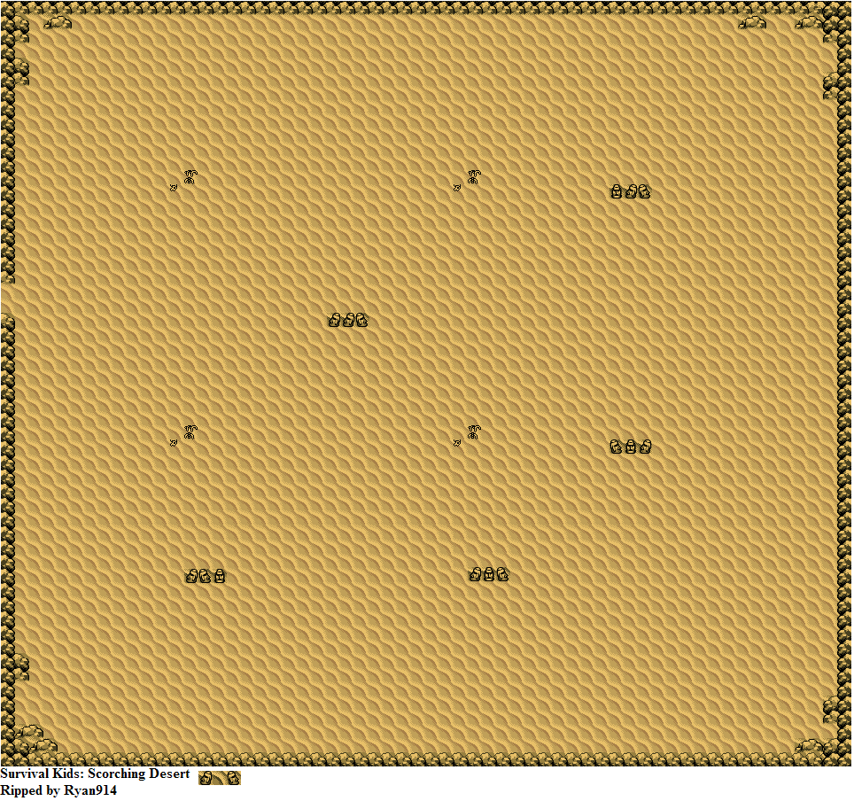**Treasure Hunters!**

**Welcome to Treasure Hunters!**

Can you guide your hunter through the treacherous desert to the pyramids?

Guide your hunter with the arrow keys and avoid the cars and gators! Catch the Holy Grail for an extra life!

Press “P” to pause.

Begin!

* Credits: Desert: <http://spritedatabase.net/files/gameboy/732/Background/SK_ScorchingDesert.png>
* Game Screen

A description...A description...A description...A description...A description...A description...A description...A description...A description...A description...A description...A description...A description...A description...A description...A description...**Treasure Hunters!**

**SCORE**

**LIVES: 3**

**TIME**

* Pause Screen

**Paused**

Guide your hunter to an open pyramid with the arrow keys and avoid the cars and gators! Catch the Holy Grail for an extra life!

Resume

A description...A description...A description...A description...A description...A description...A description...A description...A description...A description...A description...A description...A description...A description...A description...A description...**Treasure Hunters!**

**SCORE**

**LIVES: 3**

**TIME**